11.3 Oxides
Name: ____________________ Class: ____________________ Due date: 1.9
1. Air containing an acidic impurity was neutralised by passing it through a column containing substance X.
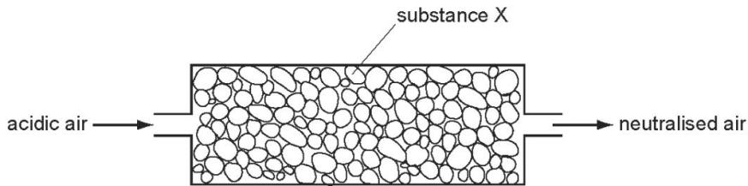
What is substance X? （ ）
A calcium oxide B sand C sodium chloride D concentrated sulfuric acid

2. Two oxides, X and Y, are added separately to dilute sulfuric acid and dilute sodium hydroxide.
X reacts with dilute sulfuric acid but Y does not react.
Y reacts with aqueous sodium hydroxide but X does not react.
Which type of oxide are X and Y? （ ）
 | acidic oxide | basic oxide | metallic oxide
A | X | Y | X
B | X | Y | Y
C | Y | X | X
D | Y | X | Y

3. Element X forms an acidic, covalent oxide.
Which row shows how many electrons there could be in the outer shell of an atom of X? （ ）
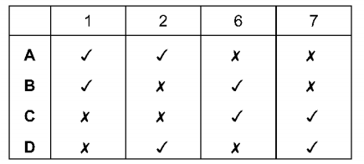

4. The diagram shows one period of the Periodic Table.
Li | Be | B | C | N | O | F | Ne
Which two elements form acidic oxides? （ ）
A carbon and lithium B carbon and neon C carbon and nitrogen D nitrogen and neon

5. Which of the following are properties of the oxides of non- metals? （ ）
 | property 1 | property 2
A | acidic | covalent
B | acidic | ionic
C | basic | covalent
D | basic | ionic
6. Element X forms an oxide, XO, that neutralises sulfuric acid.
Which row describes X and XO? （ ）
 | element X | nature of oxide, XO
A | metal | acidic
B | metal | basic
C | non-metal | acidic
D | non-metal | basic

7. Only two elements are liquid at ${20}^{∘}C$ . One of these elements is shiny and conducts electricity.
This suggests that this element is a ….1. ….. and therefore its oxide is ….2. …….
Which words correctly complete gaps 1 and 2? （ ）
 | 1 | 2
A | metal | acidic
B | metal | basic
C | non-metal | acidic
D | non-metal | basic

8. Which statement about oxides is correct? （ ）
A A solution of magnesium oxide will have a pH less than 7.
B A solution of sulfur dioxide will have a pH greater than 7.
C Magnesium oxide will react with nitric acid to make a salt.
D Sulfur dioxide will react with hydrochloric acid to make a salt.

9. Hydrochloric acid is used to clean metals.
The acid reacts with the oxide layer on the surface of the metal, forming a salt and water.
Which word describes the metal oxide? （ ）
A alloy B base C element D indicator

10. Element X is in Group I of the Periodic Table.
Which row shows the type of oxide and whether element X is metallic or non- metallic?（ ）
 | type of oxide | metallic or non-metallic
A | acidic | metallic
B | acidic | non-metallic
C | basic | metallic
D | basic | non-metallic

11. Which row describes whether an amphoteric oxide reacts with acids and bases? （ ）
 | reacts with acids | reacts with bases
A | no | no
B | no | yes
C | yes | no
D | yes | yes

12. Germanium oxide is a white powder.
Germanium oxide reacts with concentrated hydrochloric acid.
Germanium oxide reacts with concentrated aqueous sodium hydroxide.
Germanium oxide does not dissolve when added to water.
Which type of oxide is germanium oxide? （ ）
A acidic B amphoteric C basic D neutral

13. Nitrogen(I) oxide, $N2O$ , nitrogen(II) oxide, NO, and carbon monoxide, CO, are all non- metal oxides.
They do not react with acids or bases.
Which statement is correct? （ ）
A They are acidic oxides.
B They are amphoteric oxides.
C They are basic oxides.
D They are neutral oxides.

14. Which substance is a neutral oxide? （ ）
A aluminium oxide B carbon monoxide C sulfur dioxide D zinc oxide

15. Which statement about carbon monoxide and aluminium oxide is correct?（ ）
A Carbon monoxide and aluminium oxide are both amphoteric.
B Carbon monoxide and aluminium oxide are both neutral.
C Carbon monoxide is amphoteric but aluminium oxide is neutral.
D Carbon monoxide is neutral but aluminium oxide is amphoteric.

